الجمهورية اللبنانية الامتحانات الرسمية لشهادة الامتياز الفني
الاسم والشهرة:--------------------
رقم المرشح :----------------------
وزارة التربية والتعليم العالي لدورة عام 2017 الثانية
المديرية العامة للتعليم المهني والتقني
===============
الاختصاص والرمز : المعلوماتية الادارية (23102)
المادة : الشبكات المعدل : (10)
المستندات المسموح بها : الة حاسبة غير مبرمجة المدة : ساعة ونصف

Treat the following questions:
- (6 pts)
- PC1 is a computer using the following protocols of the TCP/IP model: HTTP, ICMP, TCP, DHCP, UDP, SMTP, IP and Ethernet. Put these different protocols in their appropriate layers of the TCP/IP model (4 layers scheme) by giving the name of each layer.
- Which OSI layer is responsible for MAC addressing and detection of errors through CRC calculation?
- Explain briefly the difference between a Hub and a Switch.
- What is the role of a DNS server?
- Mention two advantages for using fiber optic cable instead of UTP cable?
- State the differences between IPv4 and IPv6.
- In TCP header, what is the field that is responsible for “flow control”: port number, Receive window size or check sum?

- Refer to the following network topology. If host A sends data to host B, what will be: (1.5 pts)
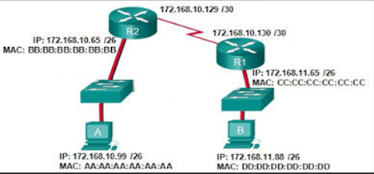
- The destination IP address in the packet when it leaves host A and R2?
- The destination and the source Mac address in the frame when it leaves host A?
- The destination Mac address in the frame when it leaves R1?
- The destination port number in the segment when it leaves host A, if host B is an SMTP (email) server?
- What is the address of the default gateway of host B?
Note: The address is represented by @ symbol in the table.
At Device | Destination MAC@ | Source  MAC@ | Source  IP@ | Destination  IP@ | Source Port number | Destination  Port number | Data
Host A | ? | ? |  | ? |  | ?
Router R2 |  |  |  | ?
Router R1 | ?
- Given below the R1 routing table. On which exit interface will R1 forward a packet destined to the IP address: (1.5 pts)
- 192.168.3.69.
- 172.16.8.2
R1 routing table
Destination Network address | Exit interface/Next hop address
192.168.1.0/24 | Fa0/0
10.0.0.4/30 | Se0/0/1
172.16.8.0/30 | Se0/0/0
0.0.0.0/0 | 10.0.0.6

الاختصاص والرمز : المعلوماتية الادارية (23102)
المادة : الشبكات

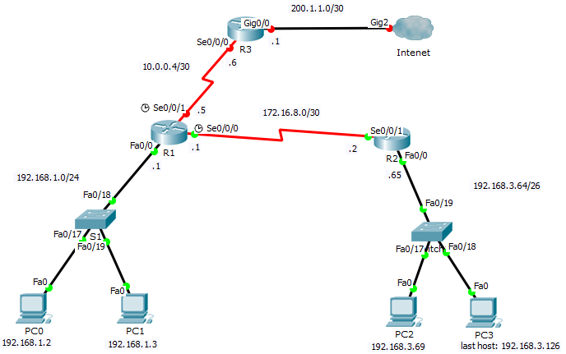

- Between the two packets of parts a) and b), the router makes incorrect decision for one of them. Give the solution (the additional entry in R1) to resolve this routing issue.
- Give the routing table of R2 in order to have full connectivity (try to minimize the number of entries in this table).

- Give two advantages for using digital transmission instead of analog transmission? (1 pt)

- Give two WAN options to connect two remote campuses one in Beirut and the other in Saida. Which option do you prefer and why? (1 pt)

- Explain how to protect your network as well as the users’ data on the hosts/servers from malicious attacks. (1.5 pts)

- A building of an industrial company is composed of 5 floors, in which is implemented a high bit rate local network containing one network printer and 50 computers (10 computers per floor) with a distance up to 100m in each floor. The local network is connected to the Internet via a DSL connection through an ISP. (2 pts)
- Draw the network architecture, including the Internet connection. Specify all equipment needed to perform the proposed architecture.
- What type of cable should be used?
- Which IP address class (A, B or C) is more suitable to use in this network? Give the default subnet mask of the chosen class.

- Given a host with the IP address 100.100.99.5/11. Determine: (2.5 pts)
- The address class.
- The address scope (public, private, ..).
- The subnet mask of this host.
- The subnet address to which belong this host.
- The number of valid hosts in this subnet.

- Consider the network address of class C: 200.35.66.0 with a subnet mask 255.255.255.240. Among the following host IP addresses which one is valid? (1 pt)
        - 200.32.66.77
        - 200.35.66.13
        - 200.35.66.88
        - 200.35.66.20

- Given the network address 140.99.0.0/16. The number of subnets required is 6. (2 pts)
- What would be the suitable subnet mask?
- What is the 5th subnet address?
- What is the broadcast address for the 4thsubnet?
- What are the valid host addresses for the 5th subnet?

